**PhonePay Data**

**Summary of Understanding**

* The dataset represents comprehensive information on digital payments in India, collected and aggregated by PhonePe.

The primary purpose of this dataset is to provide insights into the adoption and penetration of digital payments across different states in India,  As a stock analyst perspective which year would have been the best year to invest in this company.

* In a move to support the data and developer community, PhonePe launched the PhonePe Pulse Dataset API, an open data initiative that offers anonymized aggregate data on digital payments in India.
* This dataset is organised into a hierarchical structure with three major sections:

**1. Aggregated**

           The aggregated section contains summarized data across different categories:

**1.1 Insurance**: Data related to insurance metrics.

* Country: India
  + Yearly data from 2020 to 2024(Quarterly reports)
  + State-level data
* **Column Identification for Tables**





**1.2 Transaction**: Data related to financial transactions.

* Country: India
  + Yearly data from 2018 to 2024(Quarterly reports)
  + State-level data

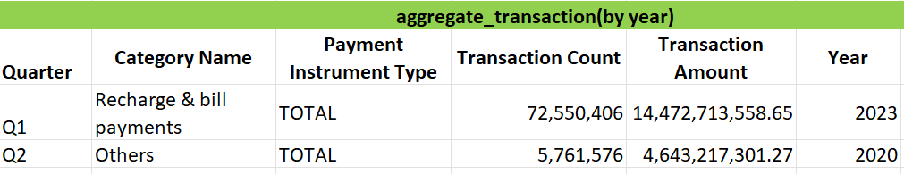

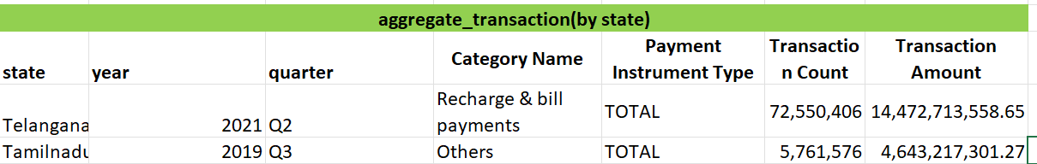

**1.3 User**: Data related to user metrics.

* Country: India
  + Yearly data from 2018 to 2024(Quarterly reports)
  + State-level data

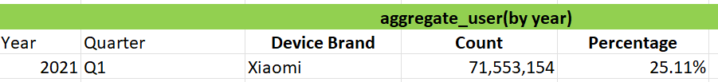

Note:similar for state level data but includes state name

**2. Map**

        The map section contains Total values at the State and District levels

**2.1 Insurance**:  State and District levels data related to insurance.

* Country: India
  + Yearly data from 2020 to 2024(Quarterly reports)
  + State-level data
* Hover: Data for interactive map features(Quarterly reports)
  + Yearly data from 2020 to 2024
  + State-level data
* **Column Identification for Tables**



**2.2 Transaction**:State and District levels data related to transactions.

* Hover/Country: India
  + Yearly data from 2018 to 2024(Quarterly reports)
  + State-level data



|  |
| --- |
|  |

**2.3 User**: State and District levels Data related to user metrics.

* Hover/Country: India
  + Yearly data from 2018 to 2024(Quarterly reports)
  + State-level data

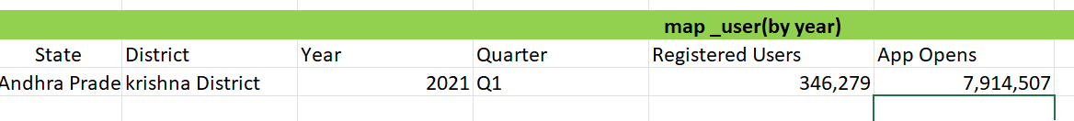

**3. Top**

The top section contains Totals of top States / Districts / Postal Codes.

**3.1 Insurance**: Top-level metrics for insurance.

* Country: India
  + Yearly data from 2020 to 2024(Quarterly reports)
  + State-level data
  + District level pincodes
* **Column Identification for Tables**

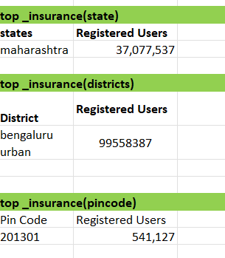

**3.2 Transaction**: Top-level metrics for transactions.

* Country: India
  + Yearly data from 2018 to 2024(Quarterly reports)
  + State-level data

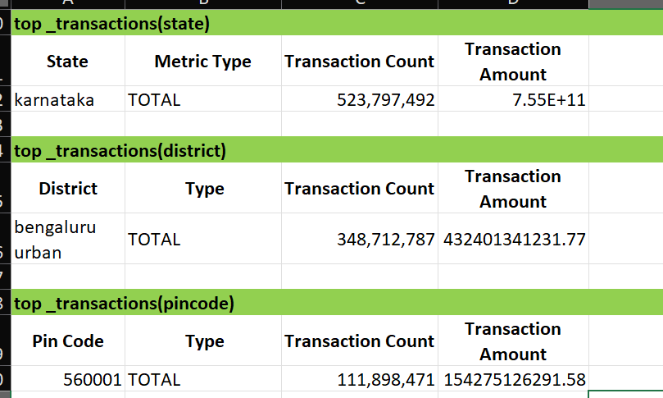

**3.3 User**: Top-level metrics for users.

* Country: India
  + Yearly data from 2018 to 2024(Quarterly reports)
  + State-level data

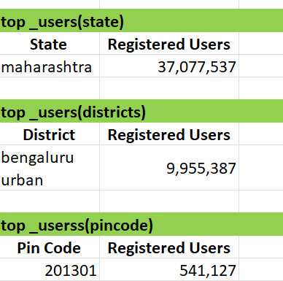

**Note:**For State wise analysis we can add State name columns for above tables.

Analysis

**1.To make an analysis of penetration of digital payments in different parts of India state wise and year wise.**

To analyze the penetration of digital payments in different parts of India, state-wise and year-wise, weneed to consider several key columns. These columns should capture the metrics that indicate digital payment usage and penetration. Based on the JSON data,the following columns would be essential:

**1. Basic Information**

* State: The name of the state.
* Year: The year of the data.

**2. Digital Payment Metrics**

* Transaction Count: The total number of transactions.
* Transaction Amount: The total value of all transactions.
* Registered Users: The number of registered users for digital payment services.
* App Opens: The number of times the digital payment app has been opened (optional but useful for gauging engagement).

**3. Additional Metrics for Deeper Insights**

* District: If you have district-level data, it can provide more granular insights.
* Pin Code: For highly detailed and localized analysis.

**Example Excel Sheet Structure**

**Sheet: Digital Payment Penetration**

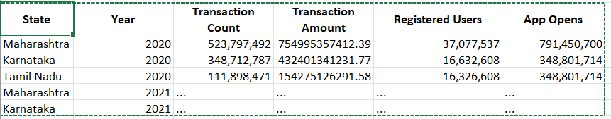

**2. As a stock analyst perspective which year would have been the best year to invest in this company.**

To determine the best year to invest in a company from a stock analyst's perspective using the phone data , we would need to consider columns that indicate the company's performance and user engagement with digital payment services. These columns can give insights into the company's growth, profitability, and market penetration.

Key Metrics to Consider

1. **Year**: The year of the data.
2. **Transaction Count**: The total number of transactions, which indicates user engagement and activity.
3. **Transaction Amount**: The total value of all transactions, reflecting the monetary volume processed.
4. **Registered Users**: The number of users registered for the service, showing user base growth.
5. **App Opens**: The number of times the app has been opened, indicating user engagement and usage frequency.

Example Analysis

Using the hypothetical data provided:

* 2020:
  + Transaction Count: 523,797,492
  + Transaction Amount: 7.549953574123948E11
  + Registered Users: 37,077,537
  + App Opens: 791,450,700
* 2021:
  + Transaction Count: (higher or lower than 2020)
  + Transaction Amount: (higher or lower than 2020)
  + Registered Users: (higher or lower than 2020)
  + App Opens: (higher or lower than 2020)

By comparing these metrics, you can identify trends such as:

* Revenue and User Base Growth: Significant increases in transaction count and amount, along with registered users, indicate strong growth.
* User Engagement: Higher app opens suggest greater user engagement and activity.